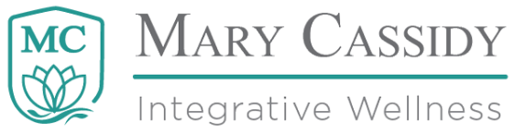
Livingston, MT 59047
406-223-2359 mary@tapoutstress.com

FAQ’s and Suggested Interview Questions
What is tapping?
Tapping is a do-it-yourself stress relief tool based on the 5000 year old practice of Chinese acupuncture which uses meridians, or lines down the body to connect points in our hands, feet, arms and legs to our body organs. With tapping we use those meridians and “tap” four points on the face when stress arises. The act of tapping releases stress by interrupting your pictures, sounds, movies and feelings, and positively alters your neural process about the stressor at hand.

How do you do tapping?
Step 1: Identify the stressor.
Step 2: Rate “it” using “Subjective Units of Distress” (SUDs) 0 to 10 scale. 0=no stress; 10=high stress, rate the one stress just identified and write that number down.
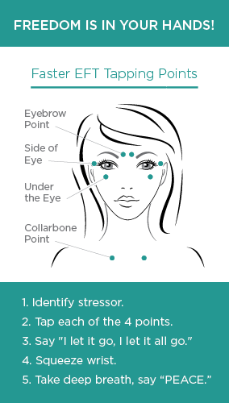
Step 3: Tap (see diagram). Tap between your eyes with two fingers, on the side of your eye, under your eye and on your collar bone saying, “Let it go” (aloud or in your mind) at each point. Take a deep breath, squeeze your wrist and say “Peace.” This is one “round” of tapping.
Step 4: Rate it again. The stress you previously identified was at a particular number prior to round one of tapping. What is it now? 0=no stress, 10=high stress. Write that number down. It generally lowers with each round of tapping.
Step 5 : Continue tapping and rating
Continue with tapping rounds until your stress reaches zero.

What can you use tapping for? Tapping can used for any physical, emotional and mental stress or strain from illness or injury.

Will It Last/Will (the problem) come back? Because EFT and FasterEFT address the problem or opportunity at a core neurological level, the presenting problem will never, ever come back in exactly the same way. And if you have successfully “collapsed” the problem at its root, you could forget that you ever had it. This is called the “Apex Effect.” However, if you have similar stressors and challenges, and you routinely think about them with emotion, worry and negative anticipation (dread), you could probably bring problems back if you wanted to do that.

How would you explain tapping in simple terms? Very simply, tapping is a “pattern interrupt.” When you experience a negative pattern (pain in some form), tapping interrupts the pattern neurologically and you feel better. There are many metaphors to explain tapping. Here are two more that can help people understand to it.

You are a house. Your brain is the electrical system that runs power through the house. When you have too many circuits running in a particular area of the house, a fuse can blow. Tapping is like flicking the breaker switch, so lights quickly come back on in that area of the house.

You are a computer. Your brain is the hard drive which runs software and other programs. Some of the programs that you run on your computer are outdated and slow (stress, stress response, etc.). Tapping interrupts the old process and simultaneously corrects, deletes and optimizes computer function and speed.

Who is Tap Out Stress and what products/services do they offer?
Tap Out Stress, a division of MC Integrative Wellness, offers relief, freedom and results through books, workshops, personal and corporate wellness programs that inspire radical health outcomes through meridian tapping. We offer sessions for individuals and groups online or in person, and teach people how to feel better fast with meridian tapping.

What is Mary Cassidy’s background?
Former EMT and COO at Southwest Chemical Dependency Program, Mary Cassidy is a speaker, corporate trainer, wellness practitioner & author of Crush Your Obstacles to Outrageous Prosperity with Tapping (2019, Amazon). Mary started Tap Out Stress and MC Integrative Wellness as a side gig in 2016, helping people overcome traumatic adversity to simple fears & phobias with tapping. In the fall of 2019, Mary left her post as COO of a state-approved chemical dependency program in Montana to pursue her dreams. She now works fulltime to provide wellness products and services through Tap Out Stress and MC Integrative Wellness.

What inspired Mary to pursue this profession?
PTSD! Mary suffered from early childhood trauma and spent most of her adult life looking for solutions that would end trauma-reactions to bad things that happened in the past. During this search, Mary found EFT tapping. Inspired by her personal relief from PTSD symptoms and triggers, along with a mounting body scientific evidence proving that tapping works on tough issues, Mary became a fulltime wellness coach and trainer.
Where does Mary see herself in the near future?
Educating people young and old about the simple benefits of learning how to tap, through books, webinars, trainings and motivational events. Mary’s vision is that meridian tapping goes viral due to celebrity and social influencer adoption and becomes a mainstream stress relief tool in 2020. In the near future, Mary fully expects to pull up at a stop light in any major city and see drivers and tapping out their stress.

How do we get a hold of Mary Cassidy?
Call or text: 406-223-2359
www.tapoutstress.com, www.mcintegrativewellness, https://www.facebook.com/?ref=logo
https://www.instagram.com/mcintegrativewellness/

